Coffee Shop Sales
1. Executive Summary
The Coffee Shop Sales Analysis project was developed to analyze the overall sales performance of a coffee shop using an interactive Excel dashboard. The dashboard provides meaningful insights into sales, customer purchasing behavior, product performance, store performance, and sales trends across different days and months.
Interactive slicers allow users to filter data by day, month, and store location, enabling quick and efficient business analysis. The dashboard helps management monitor key performance indicators (KPIs) and make data-driven business decisions.
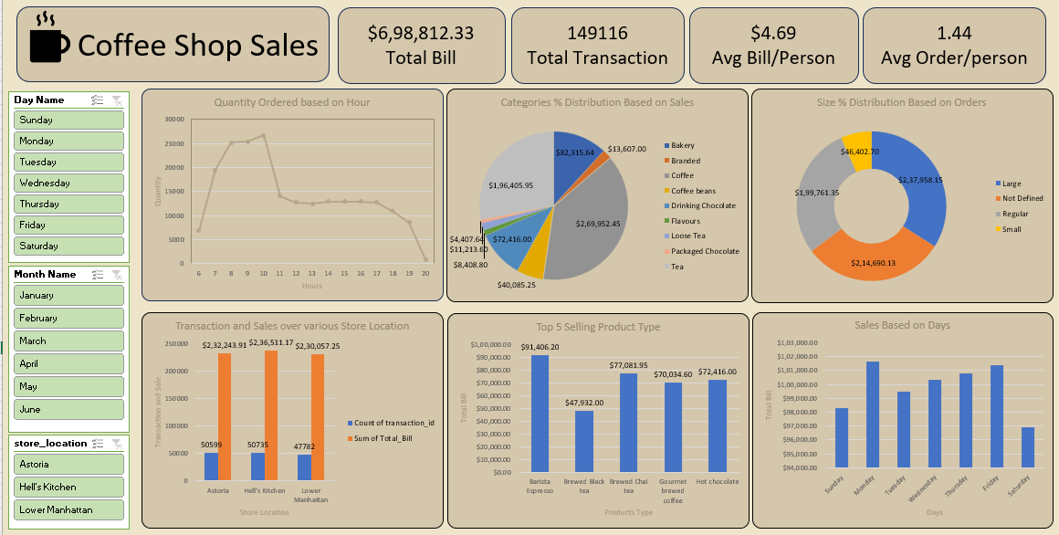
2. Business Problem
The coffee shop management wanted to answer several important business questions, including:
- What is the total revenue generated?
- How many transactions have been completed?
- Which products generate the highest sales?
- Which store location performs the best?
- During which hours do customers place the most orders?
- Which days generate the highest revenue?
- What is the distribution of product categories and order sizes?
- What is the average bill per customer?
The dashboard was created to answer these business questions in a simple and interactive manner.

3. Dataset Overview
The dataset contains transactional sales records of a coffee shop.
Dataset Includes:
- Transaction ID
- Transaction Date
- Transaction Time
- Store Location
- Product Category
- Product Type
- Product Name
- Product Size
- Quantity Ordered
- Unit Price
- Total Bill
The data was organized and summarized using Pivot Tables to build an interactive dashboard.

4. Data Cleaning
Before creating the dashboard, the dataset was cleaned and prepared for analysis.
Data Cleaning Steps
- Removed duplicate records.
- Verified and corrected date formats.
- Standardized time format.
- Checked for missing or blank values.
- Standardized product category names.
- Created calculated fields where required.
- Validated numerical data for accuracy.
These steps ensured that the dashboard generated accurate and reliable insights.

5. Dashboard KPIs
The dashboard displays four major Key Performance Indicators (KPIs).
Total Sales
The total revenue generated by the coffee shop.
Value: $698,812.33
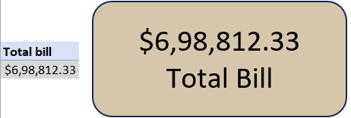

Total Transactions
The total number of completed customer transactions.
Value: 149,116
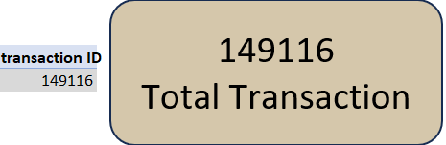

Average Bill per Customer
The average amount spent by each customer.
Value: $4.69
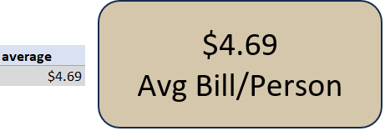

Average Orders per Customer
The average number of items purchased in each transaction.
Value: 1.44
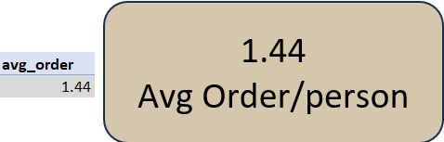

6. Dashboard Visualizations
A. Quantity Ordered Based on Hour
Purpose
This chart shows customer purchasing activity throughout the day.
Analysis
- Customer orders increase significantly during the morning hours.
- The highest order volume occurs between 8 AM and 10 AM.
- After noon, order quantity gradually decreases.
- Late evening records the lowest number of orders.
Business Insight
The coffee shop should ensure adequate staffing and inventory during peak morning hours.
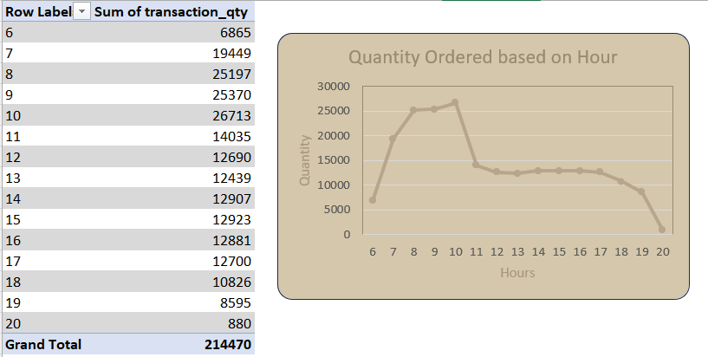
B. Category-wise Sales Distribution
Purpose
This pie chart shows the percentage contribution of each product category to total sales.
Analysis
- Coffee contributes the largest share of total sales.
- Bakery products are the second-highest revenue contributor.
- Drinking Chocolate also contributes significantly.
- Tea and Coffee Beans account for a comparatively smaller share.
Business Insight
The business should continue promoting its top-performing coffee products while introducing offers to improve sales of lower-performing categories.
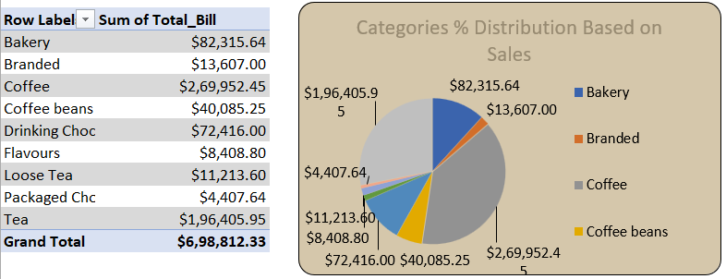
C. Order Size Distribution
Purpose
This donut chart displays customer preferences for beverage sizes.
Analysis
- Large-size beverages are ordered the most.
- "Not Defined" orders contribute a considerable share.
- Regular-size beverages are moderately popular.
- Small-size beverages account for the lowest percentage of orders.
Business Insight
Large beverages should be prioritized in inventory planning and promotional campaigns.
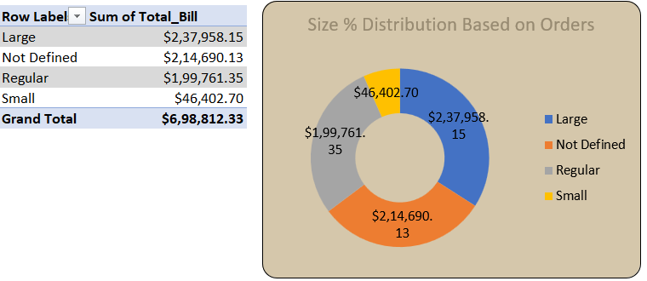
D. Store-wise Sales Performance
Purpose
This chart compares sales and transaction volume across different store locations.
Analysis
The dashboard includes three store locations:
- Astoria
- Hell's Kitchen
- Lower Manhattan
Among these stores:
- Hell's Kitchen and Astoria generate the highest revenue.
- Lower Manhattan records slightly lower sales.
Business Insight
Management can study the strategies of high-performing stores and implement similar practices in lower-performing locations.
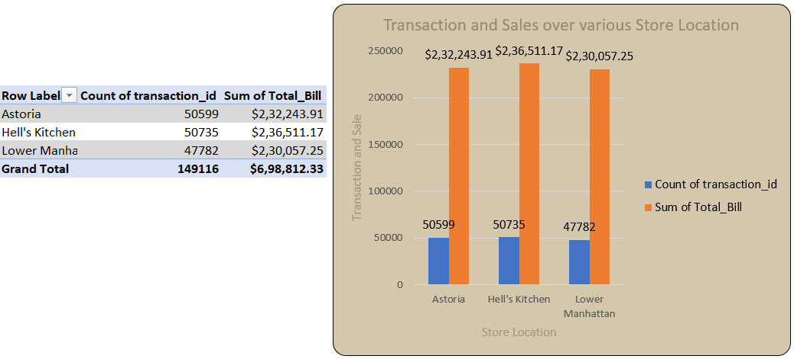
E. Top 5 Selling Product Types
Purpose
This chart identifies the products generating the highest revenue.
Top Selling Products
- Barista Espresso
- Brewed Chai Tea
- Hot Chocolate
- Gourmet Brewed Coffee
- Brewed Black Tea
Analysis
These products consistently generate high revenue and contribute significantly to overall sales.
Business Insight
Maintaining sufficient stock of these products can improve customer satisfaction and prevent stock shortages.
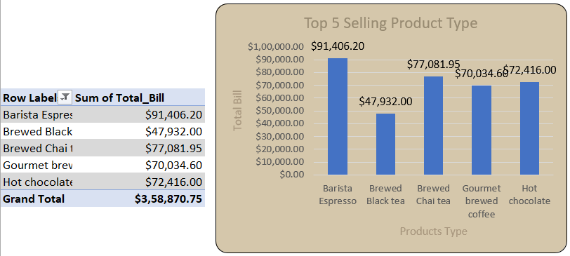
F. Sales Based on Days
Purpose
This chart compares total sales across different weekdays.
Analysis
- Monday records one of the highest sales.
- Friday also performs exceptionally well.
- Tuesday, Wednesday, and Thursday maintain stable sales.
- Saturday and Sunday show comparatively lower revenue.
Business Insight
Weekend promotional offers could help increase sales during lower-performing days.
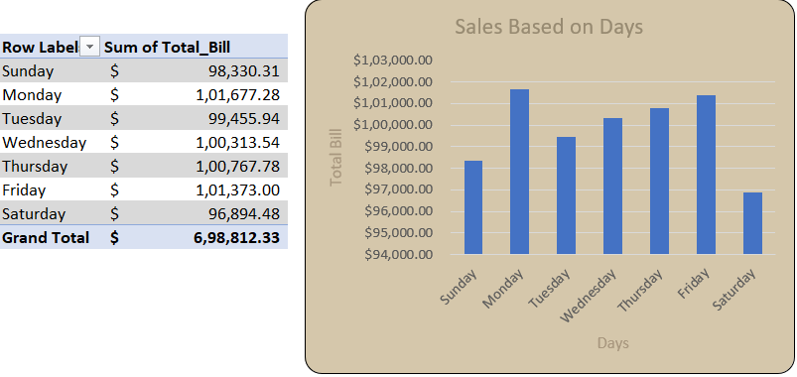

7. Dashboard Filters
The dashboard includes interactive slicers that allow users to explore the data dynamically.
Day Filter
- Sunday
- Monday
- Tuesday
- Wednesday
- Thursday
- Friday
- Saturday
Month Filter
- January
- February
- March
- April
- May
- June
Store Location Filter
- Astoria
- Hell's Kitchen
- Lower Manhattan
These filters enable users to analyze specific time periods and store locations efficiently.

8. Key Insights
- The coffee shop generated a total revenue of $698,812.33.
- A total of 149,116 transactions were completed.
- The average customer bill is $4.69.
- Customers purchase an average of 1.44 items per transaction.
- Morning hours experience the highest customer traffic.
- Coffee is the highest revenue-generating product category.
- Large-size beverages are the most popular among customers.
- Barista Espresso is the best-selling product.
- Hell's Kitchen and Astoria are the best-performing store locations.
- Monday and Friday generate higher sales compared to other weekdays.

9. Recommendations
Based on the dashboard analysis, the following recommendations are suggested:
- Increase staff availability during peak morning hours.
- Maintain higher inventory levels for best-selling products.
- Introduce promotional offers for low-performing product categories.
- Launch weekend discounts to improve Saturday and Sunday sales.
- Replicate successful business strategies from high-performing stores.
- Promote large-size beverage combo offers to maximize revenue.
- Continuously monitor KPI performance to support informed decision-making.

10. Conclusion
The Coffee Shop Sales Dashboard provides a comprehensive overview of the business's sales performance through interactive visualizations and key performance indicators. It enables management to monitor revenue, customer behavior, product performance, and store efficiency in real time.
The dashboard supports data-driven decision-making and helps identify business opportunities for increasing sales, improving customer satisfaction, and optimizing operational performance.

11. Skills Demonstrated
During this project, the following skills were applied:
- Microsoft Excel
- Data Cleaning
- Data Preparation
- Pivot Tables
- Pivot Charts
- Dashboard Design
- KPI Development
- Data Visualization
- Business Analysis
- Sales Performance Analysis
- Customer Behavior Analysis
- Interactive Reporting
- Slicer Implementation
- Analytical Thinking
- Business Intelligence Reporting

